**W1 Diesel Water Heater**

**Manual And**

**Operation Instructions**



**Dear Customer:**

Thank you for choosing to purchase our product,

Please read the instructions carefully before installing and using the water heater and keep them for future reference.

Minor features are subject to change without notice.

The schematics in the manual are for reference only, please refer to the actual product.

**Table of Contents**

Features…………………………………………1

Safety feature…………………………………1

Appearance and technical parameters…………2

Installation Notes………………………………3

Instructions for use…………………………… 4

Product Size and Description………………… 5

Instructions……………………………………6

Precautions for use……………………………6

Trouble Shooting Guide…………………………7

**Features. Safety features**

**Features**

◆**Speed**

This unit is designed to provide instantaneous hot water, no need to wait.

◆**Safety**

Over temperature protection, safe low 12volt use.

◆**Technology**

The microcomputer intelligent system automatically detects and controls the working state of the water heater.

LCD screen displays water temperature, water flow, and flame working status at a single glance.

◆**Appearance**

The quality and elegant look of the heater will compliment any application.

◆**Ease of Use**

Six settings mode dial, one power switch, temperature adjustment knob, portable movement, outdoor essentials.

**Safety features**

◆**Over temperature protection - self-test system**

The water heater uses a double over-temperature protection device to monitor the water temperature. When it is detected that the water temperature exceeds the safety limit, the water heater stops working immediately and the display will show “E3” as a reminder.

◆**Low water flow protection**

When the water flow is too low, or the water flow has ceased, the water heater will discontinue heating to avoid dry burning of the unit.

◆**Automatic pressure relief function**

When water pressure in the pipeline system exceeds the set pressure of the temperature-regulating-pressure-relief-valve, the pressure relief port will automatically relieve pressure to protect the machine and personal safety.

**WARNING** After the water heater stops working due to the above faults, you must disconnect the power immediately and contact the after-sales service. ( refer to “Common Faults”); Do not repair by yourself. Incorrect repair methods may endanger personal safety, cause property damage, and void warranty.

**Appearance and technical parameters**

**Appearance**

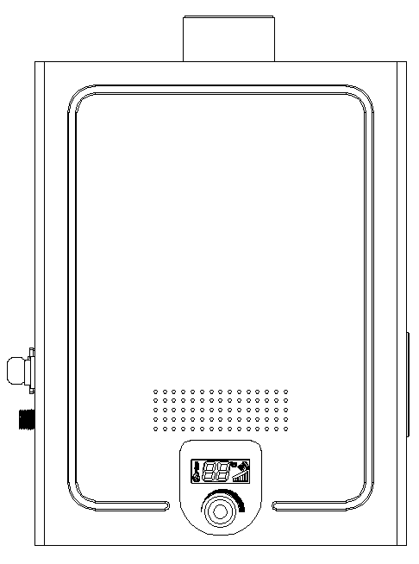

**Technical parameters**

|  |  |  |  |  |  |
| --- | --- | --- | --- | --- | --- |
| Rated electricity | Constant pressure | Maximum electricity | Net weight | Power | Dimensions |
| DC12V | 0.2~0.6MPa | 4.8 A | 12KG | 40 W | 400*150*552mm |

**Installation Notes**

The water heater should be used outdoors and at ambient temperature

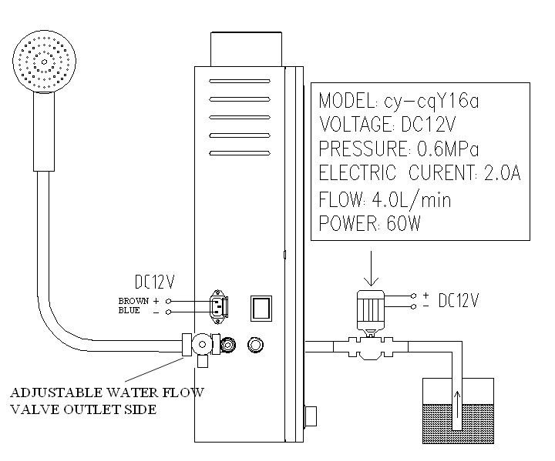

**Temperature control pressure relief valve**

A .Thermostatic relief valve installed at the water outlet side as pictured

C. Water volume required is 4.0L/min or greater

D. Under no circumstances should the pressure relief port or the draft tube be blocked.

**Instructions for use. –**

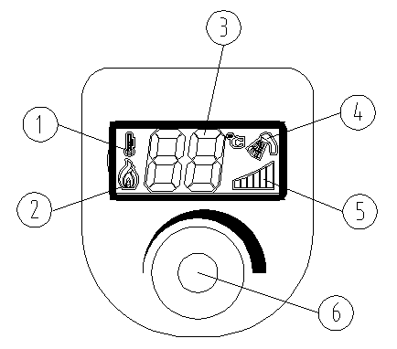

1. Start indicator
2. heat indicator
3. water temperature
4. water flow
5. Heating Level
6. Temperature and On/Off knob

STEPS

1. Connect the water source：the water pressure is pressed 0.2~0.6Mpa;
2. Connect to the power supply：12V Brown Positive, Blue Negative
3. Fill with diesel
4. First turn on the unit, the display flashes 3 times；

Press (6) - the machine will start , (1) will appear in 2-3 seconds

(2) will then light up – (If (4) flashes, the water flow is restricted or there is no water flow, it will not start. (Refer trouble shooting guide))

Now (5) should show one small bar, adjust (6) to increase/decrease the temperature.

Press (6) to stop unit when no longer required.

5. PLEASE NOTE- PLEASE ENSURE THAT WATER REGULATING TAP IS CONNECTED TO THE WATER OUTLET SIDE OF HOT WATER UNIT OTHERWISE HOT WATER UNIT WILL GO INTO OVER TEMP

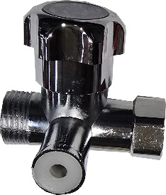

**NOTE:-** **PLEASE ENSURE WATER REGULATOR TAP IS**

**CONNECTED TO THE WATER OUTLET SIDE OF HOT**

**WATER UNIT**

**Product size**

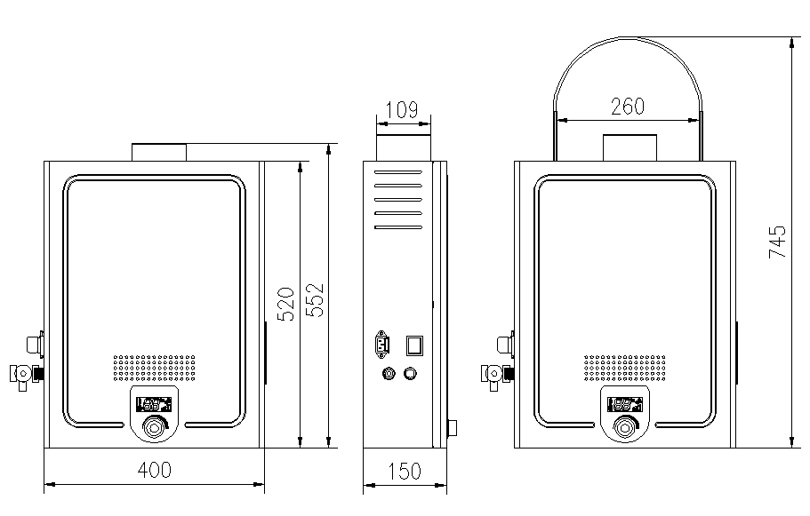

**Product structure**

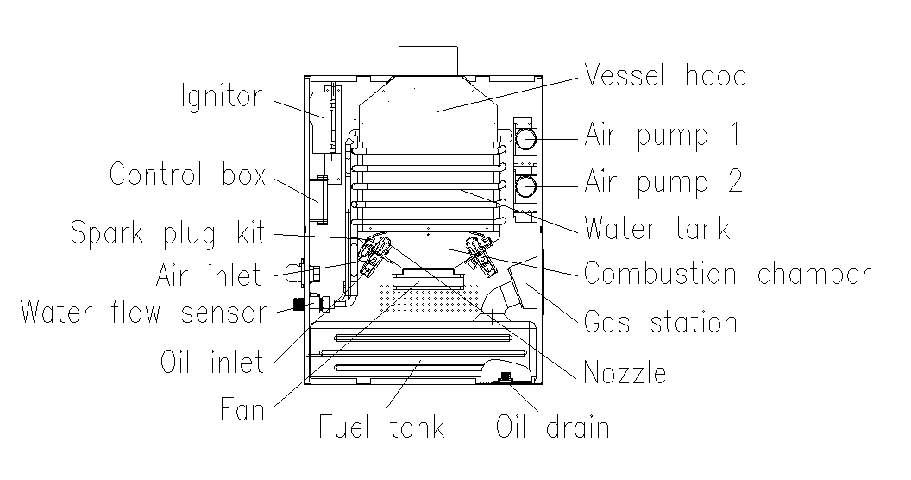

**Simple Instructions For Use**

* Connect water flow tap to Hot water outlet to water outlet side of hot water unit, no need to use thread tape on this outlet for has washer inside of water flow tap, connect outlet of water flow tap to shower or tap
* Connect water inlet hose to water heater inlet marked inlet
* Connect to DC12V power supply please note water heater is polarity sensitive, connect brown to positive and Blue to Negative, turn on the power switch, the display flashes 3 times to indicate that the power is turned on. The water heater then enters the standby mode.
* Turn the hot water, power switch to on
* Push the water temperature adjustment knob in to turn unit on a red thermostat symbol will show on display
* Turn on water outlet tap (shower head symbol will stop flashing showing you have water flow)
* Adjust hot water heater heating output by turning heat adjustment knob, the temperature display shows current water temperature
* Adjust the outlet water flow tap to also adjust the water temp (suggest 40oC is the best temp for shower etc)
* Simply turn shower or tap (water output flow) off to stop and start unit when unit registers no water flow it will go into standby mode
* Please Note do not use water inlet supply to switch unit Off/On or it will go into over temp due to no water being in heating tubes

**Precautions for use**

1. When not using the water heater, you must turn off the external power switch and water inlet switch.

2. Regularly remove any residual scale from shower head and the filter to avoid blockage.

3. Do not use acidic or alkaline cleaning solutions to wash the outside of the water heater. Only use warm soapy water and lightly wipe with a damp cloth. Please ensure power is turned off when cleaning.

4. Do not spray water onto the body of the unit during use to avoid moisture getting into the electrical components.

**Trouble Shooting Guide**

|  |  |  |  |
| --- | --- | --- | --- |
| Fault | Cause of Fault | | Solution |
| Not starting | | 1.No power | Power on |
| 2. Not enough water pressure to start the machine, the icon of the water flower in the upper right corner flashing | Increase the water volume using the relief valve |
| 3. The start button (6) is not pressed, the upper left icon is not light up | Press the knob (6) |
| Start failure | | 1. Lack of fuel | Add diesel |
| 2. High voltage package failure | Replace the high voltage package |
| 3. The ignition needle has carbon deposit | Clean up carbon deposits on the ignition needle |
| 4. Air pump failure | Replace the air pump |
| 5. Control board damaged | Replace the control panel |
| 6. The cable is loose or damaged | Check or replace the cable |
| 7. Oil nozzle tower plug | Cleaning nozzle and oil filter |
| Show“E1” | | Represents the high voltage package damage | Need to turn off the power again |
| Show“E2” | | Represents ignition failure | Need to shut down the power and start again |
| Show“E3” | | Represents over-temperature | Need to shut down the power and start again |